**PRACTICAL NO: 01**

**AIM:**To understand the different types of network cables and its types.

**THEORY:**

**INTRODUCTION:**

**NETWORK CAABLES:**

In data communication terminology, a transmission medium is a physical path between the transmitter and the receiver i.e. it is the channel through which data is sent from one place to another. Transmission Media is broadly classified into the following types:

A) GUIDED TRANSMISSION

B) UNGUIDED TRANSMISSION

**GUIDED TRANSMISSION:** It is defined as the physical medium through which the signals are transmitted. It is also known as Bounded media. Types Of Guided media:

1. Twisted pair cables
2. Coaxial cables
3. Fiber optic cables

**1.COAXIAL CABLES:**

Invented in the 1880s, coaxial cable (also called coax) was best known as the kind of cable that connected television sets to home antennas. Coaxial cable is also a standard for 10 Mbps [Ethernet cables](https://www.lifewire.com/what-is-an-ethernet-cable-817548).

When 10 Mbps Ethernet was most popular, during the 1980s and early 1990s, networks typically used one of two kinds of coax cable — thinnet (10BASE2 standard) or thicknet (10BASE5). These cables consist of an inner copper wire of varying thickness surrounded by insulation and another shielding. Their stiffness caused network administrators difficulty when installing and maintaining thinnet and thicknet.

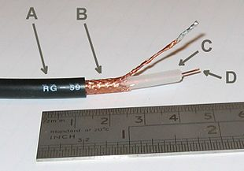

This cable contains a conductor, insulator, braiding, and sheath. The sheath covers the braiding, the braiding covers the insulation, and the insulation covers the conductor.

The following image shows these components.

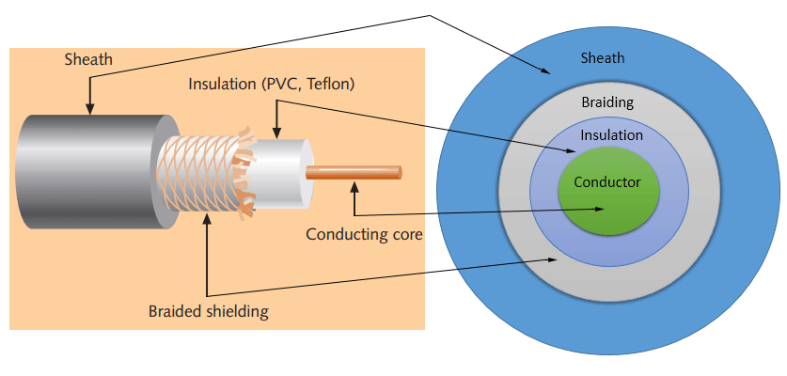

#### Sheath:

This is the outer layer of the coaxial cable. It protects the cable from physical damage.

#### Braided shield: .

This shield protects signals from external interference and noise. This shield is built from the same metal that is used to build the core.

#### Insulation:

Insulation protects the core. It also keeps the core separate from the braided shield. Since both the core and the braided shield use the same metal, without this layer, they will touch each other and create a short-circuit in the wire.

#### Conductor:

The conductor carries electromagnetic signals. Based on conductor a coaxial cable can be categorized into two types; single-core coaxial cable and multi-core coaxial cable.

A **single-core coaxial cable** uses a single central metal (usually copper) conductor, while **a multi-core coaxial cable** uses multiple thin strands of metal wires. The following image shows both types of cable.

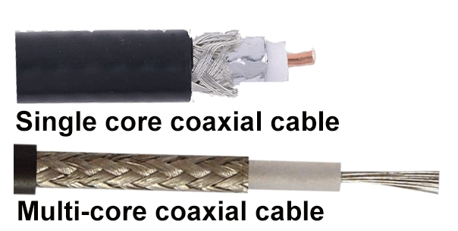

ADVANTAGES:

Following are the benefits or **advantages of Coaxial Cable**:

* Due to skin effect, coaxial cable is used in high frequency applications (> 50 MHz) using copper clad materials for center conductor. Skin effect is result of high frequency signals propagating along outer surface of the conductor. It increases tensile strength of the cable and reduces weight.
* The cost of coaxial cable is less.
* The outer conductor in coaxial cable is used to improve attenuation and shield effectiveness. This can be further enhanced with the use of second foil or braid known as jacket (C2 as designated in the figure-1). The jacket is used as protective cover from the environment and makes overall coaxial cable as flame retardant.
* **It** is less susceptible to noise or interference (EMI or RFI) compare to twisted pair cable.
* It supports high bandwidth signal transmission compare to twisted pair.
* It is easy to wire and easy to expand due to flexibility.
* It allows high transfer rates with coaxial cable having better shielding materials.

### DISADVANTAGES:

Following are the **disadvantages of Coaxial Cable**

* It is bulky.
* It is expensive to install for longer distances due to its thickness and stiffness.
* As single cable is used for signal transmission across the entire network, in case of failure in one cable the entire network will be down.
* The security is a great concern as it is easy to tap the coaxial cable by breaking it and inserting T-joint (of BNC type) in between.
* It must be grounded to prevent interference.

USES:

* **Video**

The most popular types of coaxial cable for video are RG-6 and RG-59. The latter is an industry-standard, while the RG-6 is recommended for digital signals.

* **Cctv**

For CCTV or security cameras, the RG-59 coaxial cable is best, but you can also use an RG-6 for longer distances. There are pros and cons to each cable. While the RG-6 is longer, it is also thicker, heavier, and firmer which isn’t as easy to work with as an RG-59

* **Internet:**

Coaxial cables are also used to transmit internet connections signals, but these signals run on a higher frequency than the traditional analogue. To fulfill this specific requirement, the RG-6 cable was created. It is made with a large conductor and thicker dielectric insulation that provides better signal quality. RG-6 cables are also produced with a different shielding, meaning they can transmit GHz signal levels more efficiently.

* **Tv:**

If you ask us, we recommend an RG-6 coaxial cable for television use. And not just any cable, make sure you get the best quality. A poor quality coaxial cable can result in poor TV reception. Try to look for something within 75 ohm and RG-6.

* **Hdtv**

High definition means stronger signals. This type of cable requires a higher gauge and more space for signals to transmit. The best coaxial cable for high-definition television is an RG-11.

**2.TWISTED PAIR CABLES:**

Twisted pair emerged during the 1990s as the leading cabling standard for Ethernet, starting with 10 [Mbps](https://www.lifewire.com/bits-per-second-kbps-mbps-gbps-818122) (10BASE-T, also known as Category 3 or Cat3), later followed by improved versions for 100 Mbps (100BASE-TX, Cat5, and Cat5e) and successively higher speeds up to 10 Gbps (10GBASE-T). Ethernet twisted pair cables contain up to eight wires wound together in pairs to minimize electromagnetic interference.

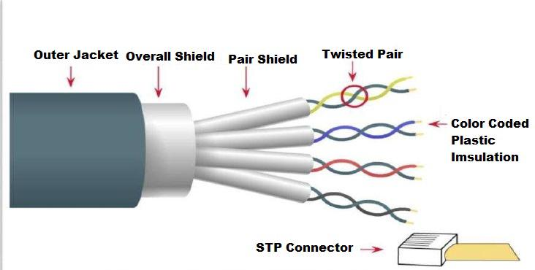

Two primary types of fiber optic cable industry standards are defined—single-mode (100BaseBX standard) and multimode (100BaseSX standard). Long-distance telecommunications networks commonly use single-mode for its relatively higher bandwidth capacity, while local networks typically use multimode due to its lower cost.

Based on how pairs are stripped in the plastic sheath, there are two types of twisted-pair cable; UTP and STP.

In the **UTP (*Unshielded twisted-pair*) cable**, all pairs are wrapped in a single plastic sheath.

In the **STP (*Shielded twisted-pair*) cable**, each pair is wrapped with an additional metal shield, then all pairs are wrapped in a single outer plastic sheath.

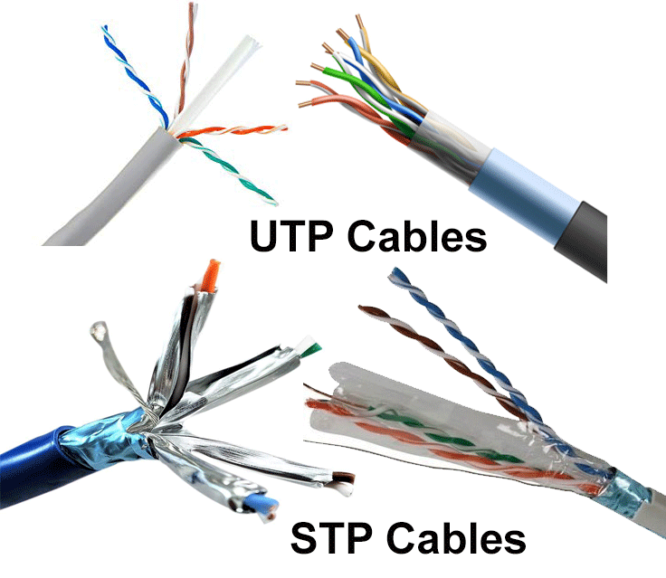

ADVANTAGES:

* It are often wont to carry both analog and digital data.
* It’s relatively easy to implement and terminate.
* It is the smallest amount expensive media of transmission for brief distances.
* If portion of a twisted pair cable is broken it doesn’t effect the whole network.
* Less vulnerable to electrical interference caused by nearby equipment or wires.
* It cause interference themselves.
* Best performance in short distances.
* High-cost performance
* The twisted-pair cable is low in weight.
* Twisted pair cable is flexible to use
* Twisted Pair cable is easy to connect.
* These cable are suitable for Data and voice infrastructure.

DISADVANTAGES:

* It result signal distortion in a very effective manner.
* Attenuation is very high.
* It supports 10 mbps upto a distance of 100 meters on a 10BASE-T which are considered to be low bandwidth.
* It provides poor security and is relatively easy to tap.
* As they a thin so can be easily breakable.
* Low durability (must be maintained regularly).
* Susceptible to electromagnetic interference (EMI).

## USES:

Twisted pair cables are prevalent in various sectors due to their versatility and efficiency in data transmission. Here are some common uses:

* **Telecommunications**: Twisted pair cables are extensively used in telephone networks where signals are transmitted digitally.
* **Computer Networks**: In local area networks (LANs), twisted pair cables are used for data transmission, connecting computers, and other network devices.
* **Video Applications**: Twisted pair cables are also utilized in video surveillance systems.

## **3.FIBER OPTICS:**

This cable consists of a core, cladding, buffer, and jacket. The core is made from thin strands of glass or plastic that can carry data over a long distance. The core is wrapped in the cladding; the cladding is wrapped in the buffer, and the buffer is wrapped in the jacket.

* Core carries the data signals in the form of light.
* Cladding reflects light back to the core.
* Buffer protects the light from leaking.
* The jacket protects the cable from physical damage.

Fiber optic cable is completely immune to EMI and RFI. This cable can transmit data over a long distance at the highest speed. It can transmit data up to 40 kilometers at the speed of 100Gbps. Fiber optic uses light to send data. It reflects light from one endpoint to another.

Two primary types of fiber optic cable industry standards are defined—single-mode (100BaseBX standard) and multimode (100BaseSX standard). Long-distance telecommunications networks commonly use single-mode for its relatively higher bandwidth capacity, while local networks typically use multimode due to its lower cost.

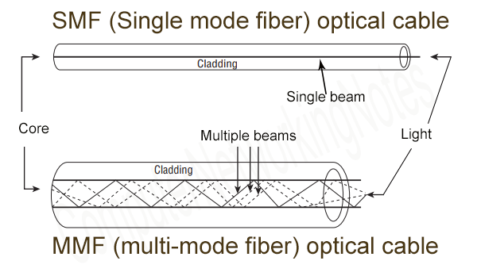.

### SMF (Single-mode fiber) optical cable:

This cable carries only a single beam of light. This is more reliable and supports much higher bandwidth and longer distances than the MMF cable. This cable uses a laser as the light source and transmits 1300 or 1550 nano-meter wavelengths of light.

### MMF (multi-mode fiber) optical cable:

This cable carries multiple beams of light. Because of multiple beams, this cable carries much more data than the SMF cable. This cable is used for shorter distances. This cable uses an LED as the light source and transmits 850 or 1300 nano-meter wavelengths of light.

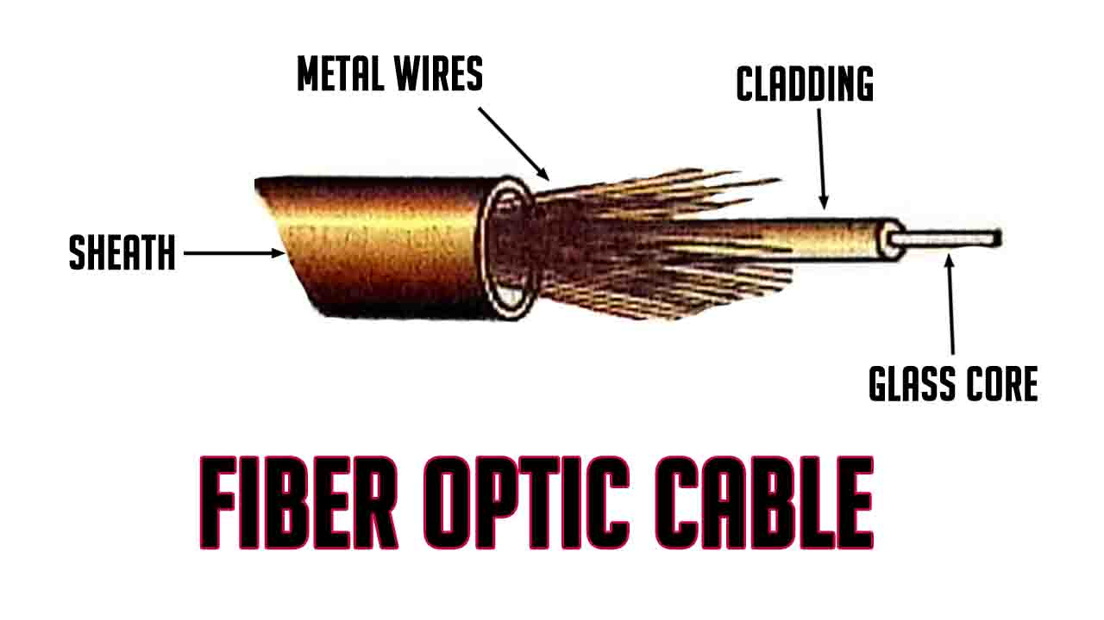

USES:

Fiber optic cables are mainly used in environments that are highly susceptible to noise and other interferences. Since these cables carry light signals, they are not prone to any interference problems. These cables are highly secure as they do not emit any external signals. Fiber optic cables are used instead of copper wires due to the following characteristics:

* **Bandwidth:** Carries huge amount of data ranging from 100 Mbps to 1Gbps.
* **Segment:**length Transmits readable data signals in a range of 2 kilometers to 100 kilometers. This allows the user to transmit data over a long distance.
* **Interference:** Secures data from being secretly read as no electrical signals pass through these types of cables. These cables can be used in areas that are highly susceptible to noise, for example, near T.V. towers, Radio stations, Electric transformers. Copper cables are prone to interference to a certain extent.

ADVANTAGES:

* Able to carry much more information as compared to **[copper cables](http://www.siemon.com/datacabling-wiring.asp)**.
* Supports much higher data rates.
* Completely immune to crosstalk, **[EMI](https://www.thomasnet.com/articles/automation-electronics/RFI-EMI-Filters)**and**RFI**.
* Much smaller and lighter in weight as compared to copper cables.
* Unaffected by chemicals and atmospheric conditions.
* Covers large distances
* This cable is much more difficult to tap into, making it a good choice for environments with security concerns.

DISADVANTAGES:

* Fiber-optic wires are difficult to install, connect and repair.
* Costly and delicate as compared to**[copper wires](http://www.siemon.com/datacabling-wiring.asp)**.
* More fragile than copper wires and difficult to split.

**UNGUIDED TRANSMISSION**:

An unguided transmission transmits the electromagnetic waves without using any physical medium. Therefore it is also known as wireless transmission. In unguided media, air is the media through which the electromagnetic energy can flow easily. Unguided transmission is broadly classified into three categories:

* + 1. Radio waves
    2. Microwaves
    3. Infrared waves

**1.RADIO WAVES:**

* Radio waves are the electromagnetic waves that are transmitted in all the directions of free space.
* Radio waves are omnidirectional, i.e., the signals are propagated in all the directions.
* The range in frequencies of radio waves is from 3Khz to 1 khz.
* In the case of radio waves, the sending and receiving antenna are not aligned, i.e., the wave sent by the sending antenna can be received by any receiving antenna.
* An example of the radio wave is FM radio.

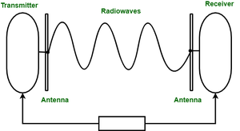

APPLICATIONS OF RADIO WAVES:

* + - A Radio wave is useful for multicasting when there is one sender and many receivers.
    - An FM radio, television, cordless phones are examples of a radio wave. Advantages Of Radio transmission:
    - Radio transmission is mainly used for wide area networks and mobile cellular phones.
    - Radio waves cover a large area, and they can penetrate the walls.
    - Radio transmission provides a higher transmission rate.

**2.MICROWAVES**:

It is a line of sight transmission i.e. the sending and receiving antennas need to be properly aligned with each other. The distance covered by the signal is directly proportional to the height of the antenna. Frequency Range:1GHz – 300GHz. These are majorly used for mobile phone communication and television distribution.

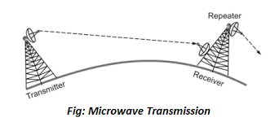

Microwaves are of two types:

1. Terrestrial microwave:
2. Satellite microwave communication.
3. TERRESTRIAL MICROWAVE TRANSMISSION
   * + Terrestrial Microwave transmission is a technology that transmits the focused beam of a radio signal from one ground-based microwave transmission antenna to another.
     + Microwaves are the electromagnetic waves having the frequency in the range from 1GHz to 1000 GHz.
     + Microwaves are unidirectional as the sending and receiving antenna is to be aligned, i.e., the waves sent by the sending antenna are narrowly focussed.
     + In this case, antennas are mounted on the towers to send a beam to another antenna which is km away.
     + It works on the line of sight transmission, i.e., the antennas mounted on the towers are the direct sight of each other.

Characteristics Of Microwave:

* + - Frequency range: The frequency range of terrestrial microwave is from 4-6 GHz to 21-23 GHz.
    - Bandwidth: It supports the bandwidth from 1 to 10 Mbps.
    - Short distance: It is inexpensive for short distance.
    - Long distance: It is expensive as it requires a higher tower for a longer distance.
    - Attenuation: Attenuation means loss of signal. It is affected by environmental conditions and antenna size.

Advantages:

* + - Microwave transmission is cheaper than using cables.
    - It is free from land acquisition as it does not require any land for the installation of cables.
    - Microwave transmission provides an easy communication in terrains as the installation of cable in terrain is quite a difficult task.
    - Communication over oceans can be achieved by using microwave transmission.

Disadvantages Of Microwave Transmission:

* + - **Eavesdropping:** An eavesdropping creates insecure communication. Any malicious user can catch the signal in the air by using its own antenna.
    - **Out of phase signal:** A signal can be moved out of phase by using microwave transmission.
    - **Susceptible to weather condition:** A microwave transmission is susceptible to weather condition. This means that any environmental change such as rain, wind can distort the signal.
    - **Bandwidth limited:** Allocation of bandwidth is limited in the case of microwave transmission.

B..SATELLITE MICROWAVE COMMUNICATION

* + - A satellite is a physical object that revolves around the earth at a known height.
    - Satellite communication is more reliable nowadays as it offers more flexibility than cable and fibre optic systems.
    - We can communicate with any point on the globe by using satellite communication. How Does Satellite work? The satellite accepts the signal that is transmitted from the earth station, and it amplifies the signal. The amplified signal is retransmitted to another earth station.

Advantages Of Satellite Microwave Communication:

* + - The coverage area of a satellite microwave is more than the terrestrial microwave.
    - The transmission cost of the satellite is independent of the distance from the centre of the coverage area.
    - Satellite communication is used in mobile and wireless communication applications. ♣ It is easy to install.
    - It is used in a wide variety of applications such as weather forecasting, radio/TV signal broadcasting, mobile communication, etc.

Disadvantages Of Satellite Microwave :

**1.Communication**:

* Satellite designing and development requires more time and higher cost.
* The Satellite needs to be monitored and controlled on regular periods so that it remains in orbit.
* The life of the satellite is about 12-15 years. Due to this reason, another launch of the satellite has to be planned before it becomes non-functional.

**3.INFRARED WAVES**:

* An infrared transmission is a wireless technology used for communication over short ranges.
* The frequency of the infrared in the range from 300 GHz to 400 THz.
* It is used for short-range communication such as data transfer between two cell phones, TV remote operation, data transfer between a computer and cell phone resides in the same closed area.

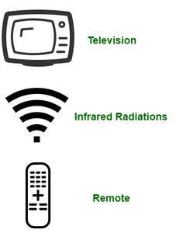

Characteristics Of Infrared**:**

* It supports high bandwidth, and hence the data rate will be very high
* Infrared waves cannot penetrate the walls. Therefore, the infrared communication in one room cannot be interrupted by the nearby rooms.
* An infrared communication provides better security with minimum interference.
* Infrared communication is unreliable outside the building because the sun rays will interfere with the infrared waves.

**NETWORK TOPOLGY**

In Computer Network ,there are various ways through which different components are connected to one another. **Network Topology** is the way that defines the structure, and how these components are connected to each other.

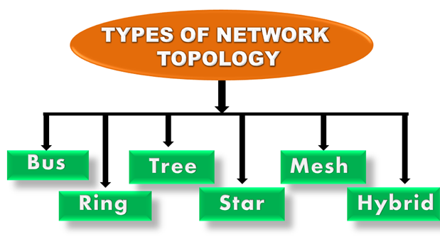

## **Types of Network Topology:**

The arrangement of a network that comprises nodes and connecting lines via sender and receiver is referred to as **Network Topology**. The various network topologies are:

* Point to Point Topology
* Mesh Topology
* Star Topology
* Bus Topology
* Ring Topology
* Tree Topology
* Hybrid Topology

### 1.POINT TO POI NT TOPOLOGY

[Point-to-Point Topology](https://www.geeksforgeeks.org/difference-between-point-to-point-link-and-star-topology-network/) is a type of topology that works on the functionality of the sender and receiver. It is the simplest communication between two nodes, in which one is the sender and the other one is the receiver. Point-to-Point provides high bandwidth.

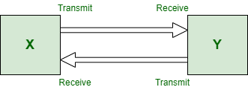

*Point to Point Topology*

### **Advantages of Point-to-Point Topology:**

* Very easy to maintain. You can replace a wire within a few seconds if the wire has a problem.
* Maximum utilization of the underlying connecting link bandwidth.
* This is the simplest topology compared to any other network topology type.
* Most minor delays in communication as compared to any other network connection type.
* Low-cost option when you have only two nodes to connect

### **Disadvantages of Point-to-Point Topology:**

* The network performance depends on a single link only. If the link is down, the entire network stops working.
* Because of the need for a direct connection, topology can not be expanded to a large area. E.g., if there is a multistory building, two computers may be far apart.
* There is only one server or client. If anyone fails, all will stop working. You can not take advantage of the network cluster. Not suitable for any database servers.
* Only applicable when the two devices are in proximity to each other such as connecting a printer.

### 2.MESH TOPOLOGY

In a mesh topology, every device is connected to another device via a particular channel. In [Mesh Topology](https://www.geeksforgeeks.org/difference-between-star-and-mesh-topology/), the protocols used are AHCP (Ad Hoc Configuration Protocols), DHCP (Dynamic Host Configuration Protocol), etc.

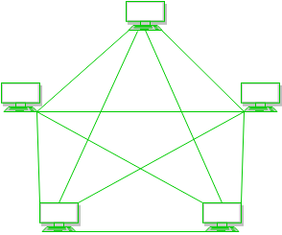

*Mesh Topology*

**Figure 1**:Every device is connected to another via dedicated channels. These channels are known as links.

* Suppose, the N number of devices are connected with each other in a mesh topology, the total number of ports that are required by each device is N-1. In Figure 1, there are 5 devices connected to each other, hence the total number of ports required by each device is 4. The total number of ports required = N * (N-1).
* Suppose, N number of devices are connected with each other in a mesh topology, then the total number of dedicated links required to connect them is NC2 i.e. N(N-1)/2. In Figure 1, there are 5 devices connected to each other, hence the total number of links required is 5*4/2 = 10.

**Advantages of Mesh Topology:**

* Communication is very fast between the nodes.
* Mesh Topology is robust.
* The fault is diagnosed easily. Data is reliable because data is transferred among the devices through dedicated channels or links.
* Provides security and privacy.

**Drawbacks of Mesh Topology:**

* Installation and configuration are difficult.
* The cost of cables is high as bulk wiring is required, hence suitable for less number of devices.
* The cost of maintenance is high.

A common example of mesh topology is the internet backbone, where various internet service providers are connected to each other via dedicated channels. This topology is also used in military communication systems and aircraft navigation systems.

.

### 3.STAR TOPOLOGY

In [Star Topology](https://www.geeksforgeeks.org/difference-between-star-and-ring-topology/), all the devices are connected to a single hub through a cable. This hub is the central node and all other nodes are connected to the central node. The hub can be passive in nature i.e., not an intelligent hub such as broadcasting devices, at the same time the hub can be intelligent known as an active hub. Active hubs have repeaters in them. Coaxial cables or RJ-45 cables are used to connect the computers. In Star Topology, many popular Ethernet LAN protocols are used as CD(Collision Detection), CSMA (Carrier Sense Multiple Access), etc.

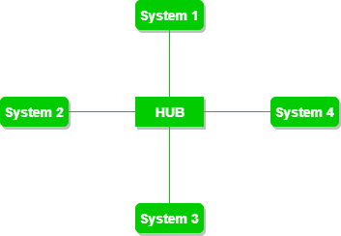

*Star Topology*

**Figure 2**: A star topology having four systems connected to a single point of connection i.e. hub.

**Advantages of Star Topology:**

* If N devices are connected to each other in a star topology, then the number of cables required to connect them is N. So, it is easy to set up.
* Each device requires only 1 port i.e. to connect to the hub, therefore the total number of ports required is N.
* It is Robust. If one link fails only that link will affect and not other than that.
* Easy to fault identification and fault isolation.
* Star topology is cost-effective as it uses inexpensive coaxial cable.

**Drawbacks of Star Topology:**

* If the concentrator (hub) on which the whole topology relies fails, the whole system will crash down.
* The cost of installation is high.
* Performance is based on the single concentrator i.e. hub.

A common example of star topology is a local area network (LAN) in an office where all computers are connected to a central hub. This topology is also used in wireless networks where all devices are connected to a wireless access point.

### 4.BUS TOPOLOGY

[Bus Topology](https://www.geeksforgeeks.org/difference-between-star-topology-and-bus-topology/) is a network type in which every computer and network device is connected to a single cable. It is bi-directional. It is a multi-point connection and a non-robust topology because if the backbone fails the topology crashes. In Bus Topology, various MAC (Media Access Control) protocols are followed by LAN ethernet connections like TDMA, Pure Aloha, CDMA, Slotted Aloha, etc.

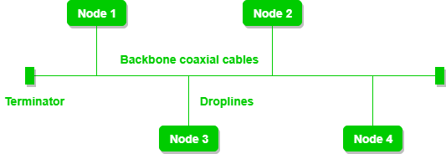

**Figure 3**:

A bus topology with shared backbone cable. The nodes are connected to the channel via drop lines.

**Advantages of Bus Topology:**

* If N devices are connected to each other in a bus topology, then the number of cables required to connect them is 1, known as backbone cable, and N drop lines are required.
* Coaxial or twisted pair cables are mainly used in bus-based networks that support up to 10 Mbps.
* The cost of the cable is less compared to other topologies, but it is used to build small networks.
* Bus topology is familiar technology as installation and troubleshooting techniques are well known.
* [CSMA](https://www.geeksforgeeks.org/carrier-sense-multiple-access-csma/) is the most common method for this type of topology.

**Drawbacks of  Bus Topology**

* A bus topology is quite simpler, but still, it requires a lot of cabling.
* If the common cable fails, then the whole system will crash down.
* If the network traffic is heavy, it increases collisions in the network. To avoid this, various protocols are used in the MAC layer known as Pure Aloha, Slotted Aloha, CSMA/CD, etc.
* Adding new devices to the network would slow down networks.
* Security is very low.

A common example of bus topology is the Ethernet LAN, where all devices are connected to a single coaxial cable or twisted pair cable. This topology is also used in cable television networks.

### 5.RING TOPOLOGY

In a [Ring Topology](https://www.geeksforgeeks.org/difference-between-ring-topology-and-tree-topology/), it forms a ring connecting devices with exactly two neighboring devices. A number of repeaters are used for Ring topology with a large number of nodes, because if someone wants to send some data to the last node in the ring topology with 100 nodes, then the data will have to pass through 99 nodes to reach the 100th node. Hence to prevent data loss repeaters are used in the network.

The data flows in one direction, i.e. it is unidirectional, but it can be made bidirectional by having 2 connections between each Network Node, it is called Dual Ring Topology. In-Ring Topology, the Token Ring Passing protocol is used by the workstations to transmit the data.

* **Token passing:**It is a network access method in which a token is passed from one node to another node.
* **Token:**It is a frame that circulates around the network.

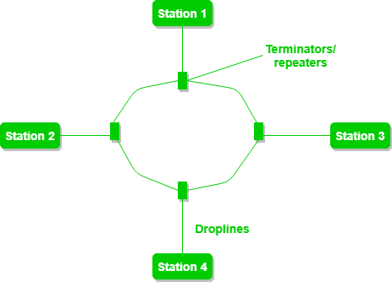

*Ring Topology*

**Figure 4**: A ring topology comprises 4 stations connected with each forming a ring.

The most common access method of ring topology is token passing.

**Operations of Ring Topology:**

1. One station is known as a **monitor** station which takes all the responsibility for performing the operations.
2. To transmit the data, the station has to hold the token. After the transmission is done, the token is to be released for other stations to use.
3. When no station is transmitting the data, then the token will circulate in the ring.
4. There are two types of token release techniques: **Early token release** releases the token just after transmitting the data and **Delayed token release** releases the token after the acknowledgment is received from the receiver.

**Advantages of Ring Topology:**

* The data transmission is high-speed.
* The possibility of collision is minimum in this type of topology.
* Cheap to install and expand.
* It is less costly than a star topology.

**Drawbacks of Ring Topology:**

* The failure of a single node in the network can cause the entire network to fail.
* Troubleshooting is difficult in this topology.
* The addition of stations in between or the removal of stations can disturb the whole topology.
* Less secure.

### ****6.TREE TOPOLOGY****

This topology is the variation of the Star topology. This topology has a hierarchical flow of data. In [Tree Topology](https://www.geeksforgeeks.org/difference-between-star-topology-and-tree-topology/), protocols like DHCP and SAC (Standard Automatic Configuration ) are used.

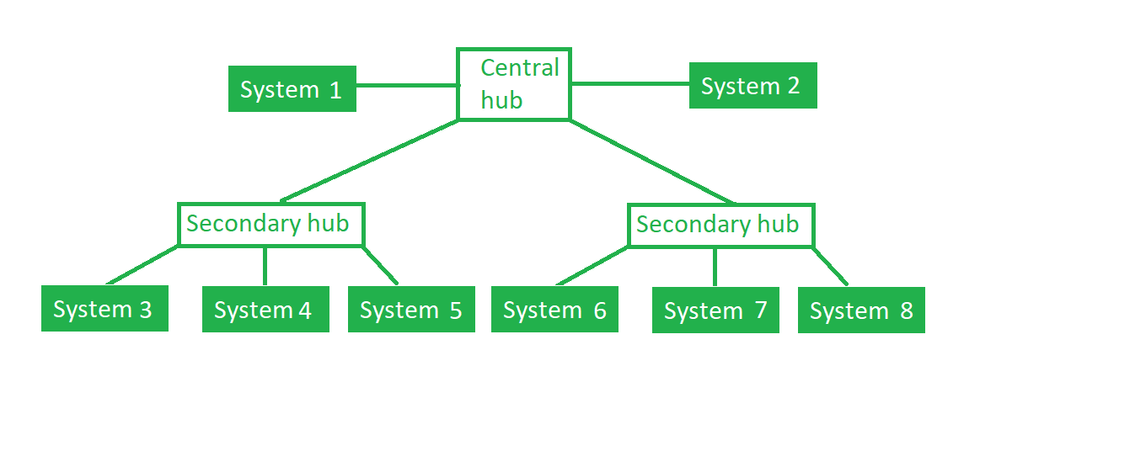

*Tree Topology*

**Figure 5**: In this, the various secondary hubs are connected to the central hub which contains the repeater. This data flow from top to bottom i.e. from the central hub to the secondary and then to the devices or from bottom to top i.e. devices to the secondary hub and then to the central hub. It is a multi-point connection and a non-robust topology because if the backbone fails the topology crashes.

**Advantages of Tree Topology:**

* It allows more devices to be attached to a single central hub thus it decreases the distance that is traveled by the signal to come to the devices.
* It allows the network to get isolated and also prioritize from different computers.
* We can add **new devices to the existing network.**
* **Error detection** and **error correction** are very easy in a tree topology.

**Drawbacks of Tree Topology:**

* If the central hub gets fails the entire system fails.
* The cost is high because of the cabling.
* If new devices are added, it becomes difficult to reconfigure.

A common example of a tree topology is the hierarchy in a large organization. At the top of the tree is the CEO, who is connected to the different departments or divisions (child nodes) of the company. Each department has its own hierarchy, with managers overseeing different teams (grandchild nodes). The team members (leaf nodes) are at the bottom of the hierarchy, connected to their respective managers and departments.

### 7.HYBRID TOPOLGY

This topological technology is the combination of all the various types of topologies we have studied above. Hybrid Topology is used when the nodes are free to take any form. It means these can be individuals such as Ring or Star topology or can be a combination of various types of topologies seen above. Each individual topology uses the protocol that has been discussed earlier.

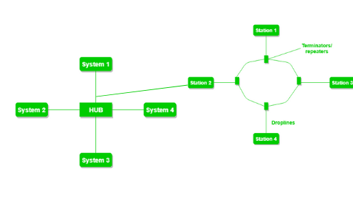

*Hybrid Topology*

**Figure 6**: The above figure shows the structure of the Hybrid topology. As seen it contains a combination of all different types of networks.

**Advantages of Hybrid Topology;**

* This topology is **very flexible**.
* The size of the network can be easily expanded by **adding new devices.**

**Drawbacks of Hybrid Topology:**

* It is challenging**to design the architecture** of the Hybrid Network.
* **Hubs**used in this topology are**very expensive.**
* The infrastructure cost is very high as a hybrid network **requires a lot of cabling and network devices**.

A common example of a hybrid topology is a university campus network. The network may have a backbone of a star topology, with each building connected to the backbone through a switch or router. Within each building, there may be a bus or ring topology connecting the different rooms and offices. The wireless access points also create a mesh topology for wireless devices. This hybrid topology allows for efficient communication between different buildings while providing flexibility and redundancy within each building..